Create a chart showing total sales for each customer
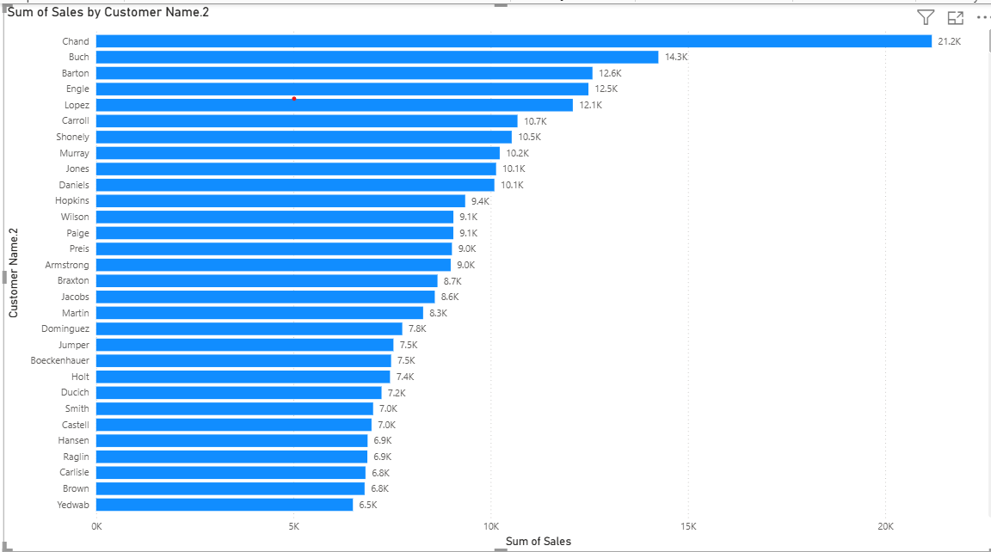
Create a chart showing the total sales by month over the years
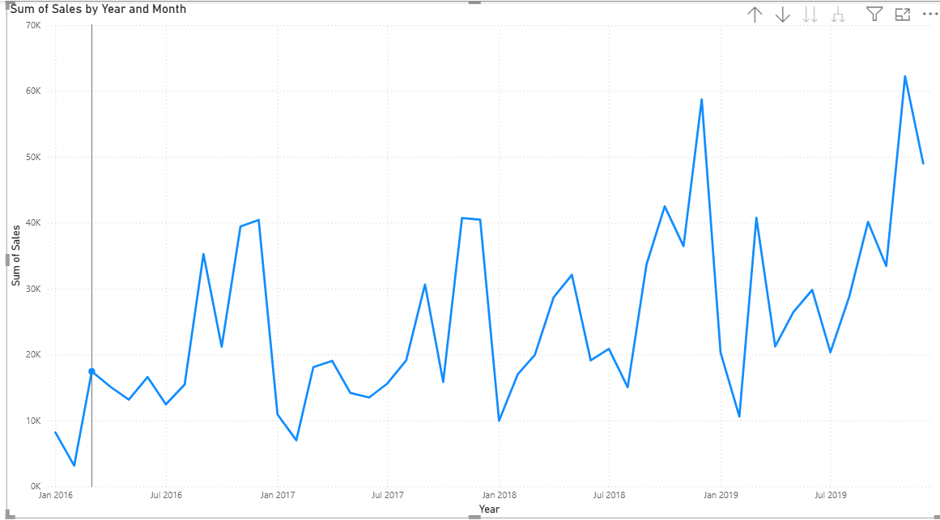

Create a pie chart showing the distribution of sales by ship mode
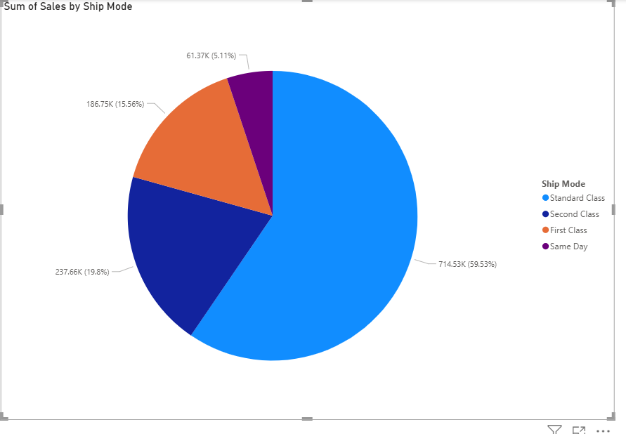

Showing the total profit for each region
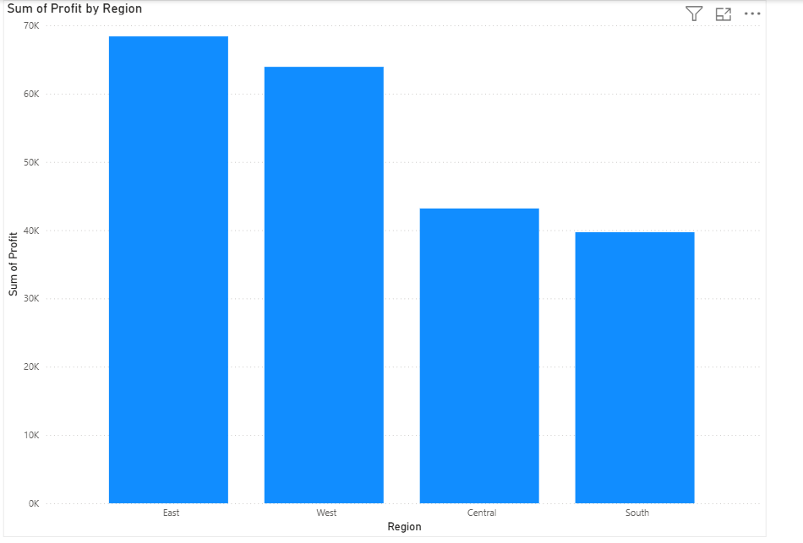

Create a bar chart showing total sales and total profit for each product category.
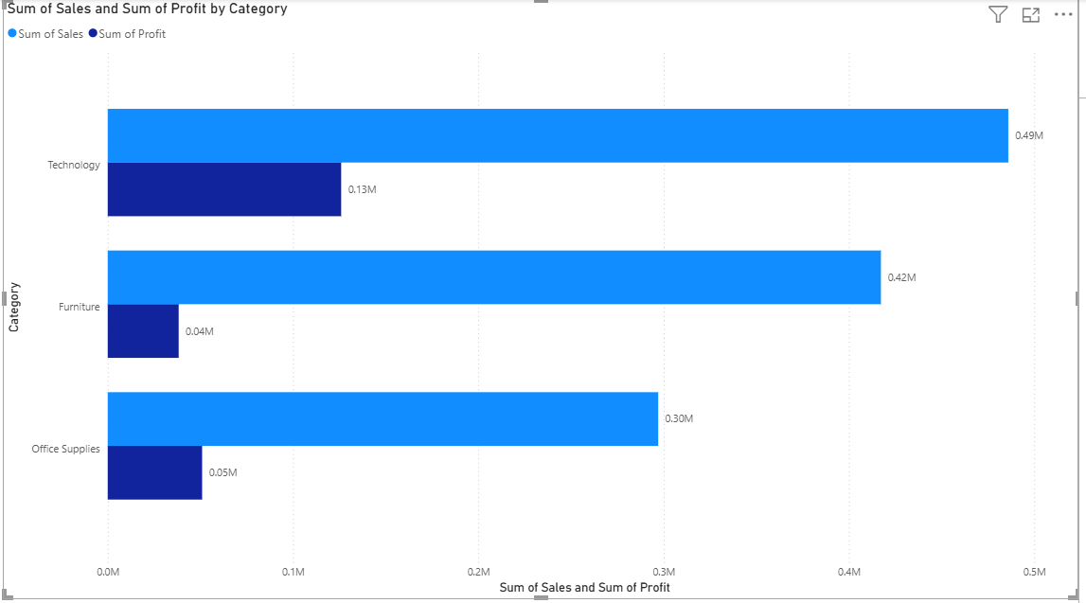
Showing total sales for each product sub-category.
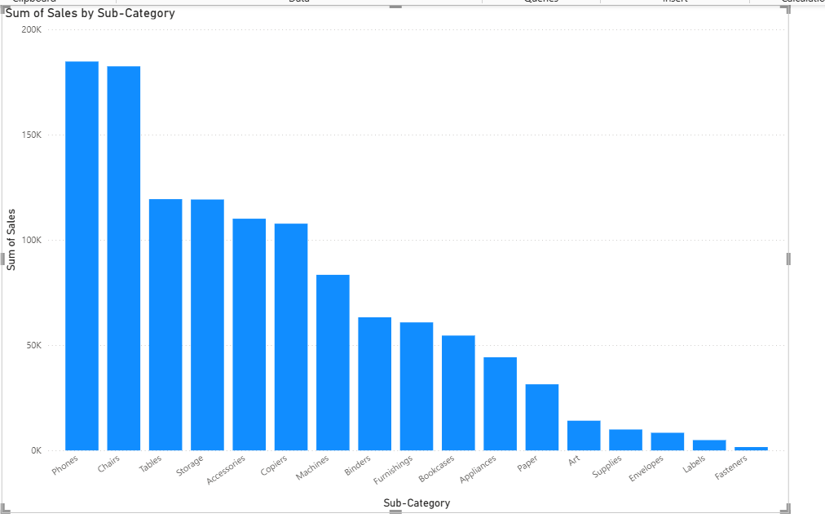

Create a chart with dual axes showing sales and quantity sold by order date.
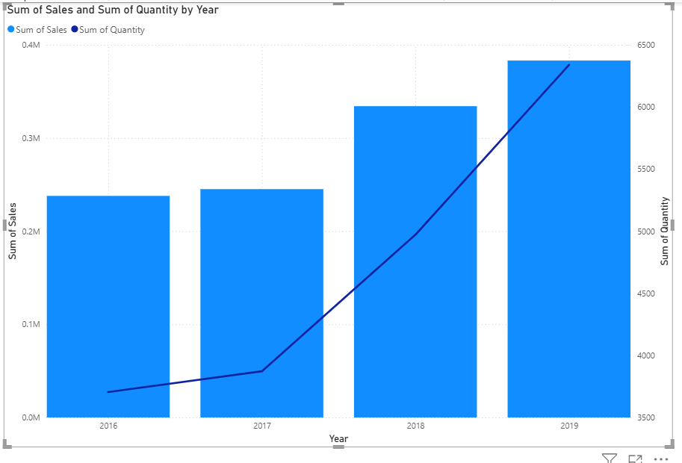

Showing the top 10 products by total sales.
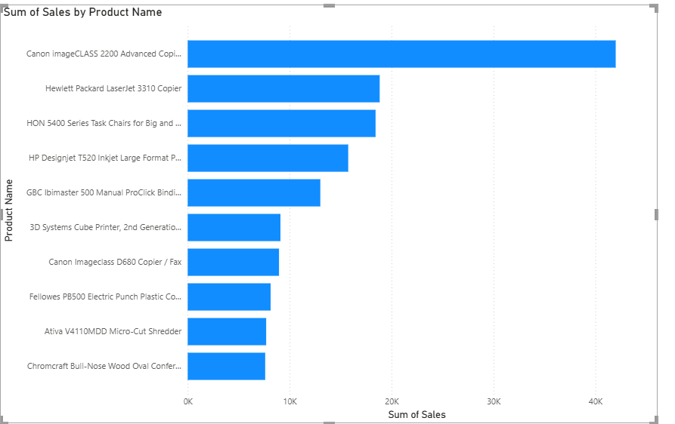

Create a map visualization showing total sales for each city.
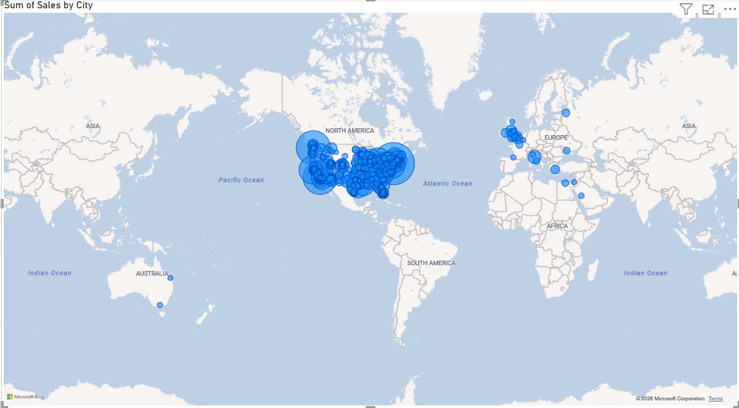

Create a scatter plot showing the relationship between discount and profit.
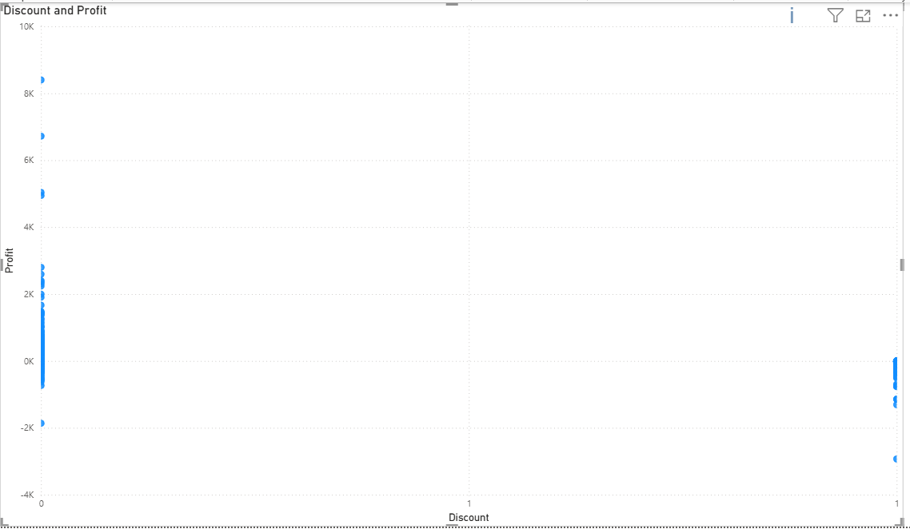
Total Sales Calculation
Total Sales = SUM(Sales[Sales])
Total Profit Calculation
Total Profit = SUM (Sales[Profit])
Sales by Customer Calculation
Sales by Customer = Sum(Sales[Sales])
Average Discount Calculation
Average Discount = AVERAGE(Sales[Discount])
Total Quantity Calculation
Total Quantity = SUM(Sales[Quantity])
Profit Margin Calculation
Total Profit = SUM (Sales[Profit])
Sales by Product Category Calculation
Sales by Product Category = Sum(Sales[Sales])
Top 5 Customers by Sales Calculation
Customer Rank = RANKX(
ALL(Sales[Customer Name]),
[Total Sales],
,
DESC
)
Top 5 Customers Sales =
IF([Customer Rank] <= 5, [Total Sales])
Year-over-Year Sales Growth Calculation
YoY Sales Growth =
VAR CurrentYearSales = CALCULATE([Total Sales], YEAR(Sales[Order Date]) = YEAR(TODAY()))
VAR PreviousYearSales = CALCULATE([Total Sales], YEAR(Sales[Order Date]) = YEAR(TODAY()) - 1)
RETURN DIVIDE(CurrentYearSales - PreviousYearSales, PreviousYearSales, 0)
Total Sales for Each Ship Mode Calculation
Sales by Ship Mode = SUM(Sales[Sales])

Create a chart showing average sales for each customer
Average Sales = Average(Sales[Sales])
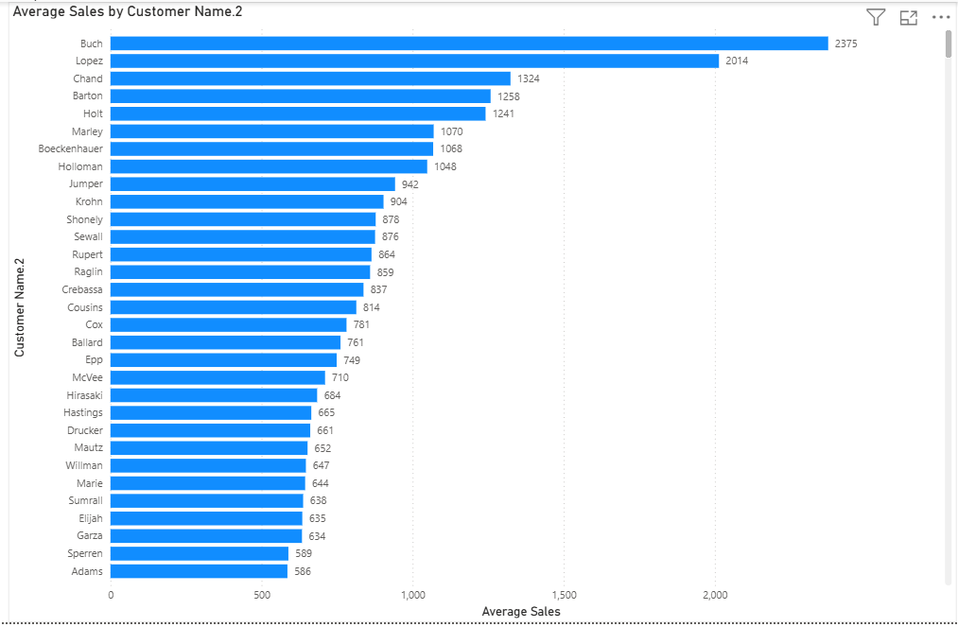
Create a chart showing cumulative sales over time
Cumulative Sales =
CALCULATE(
[Total Sales],
FILTER(
ALLSELECTED(Sales[Order Date]),
Sales[Order Date] <= MAX(Sales[Order Date])
)
)
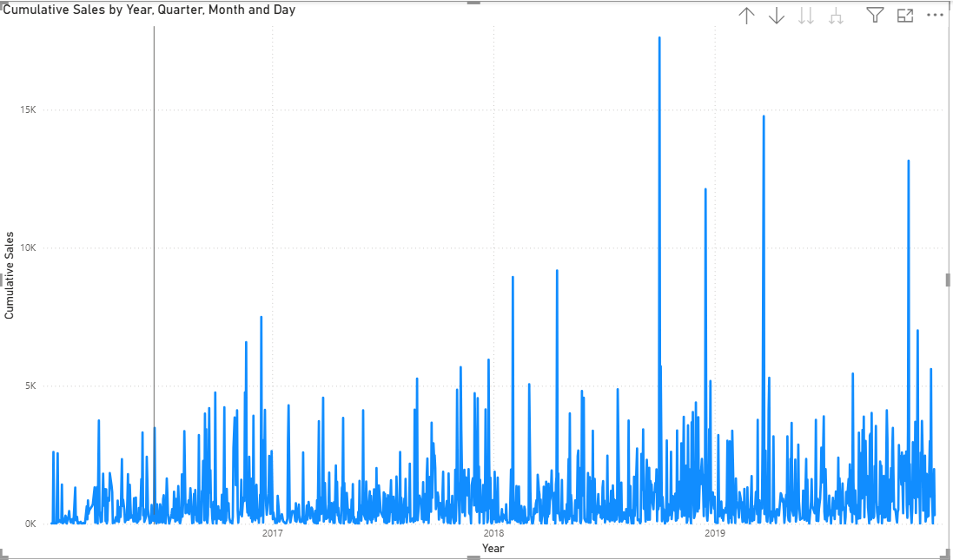
Create a chart showing sales by year and category

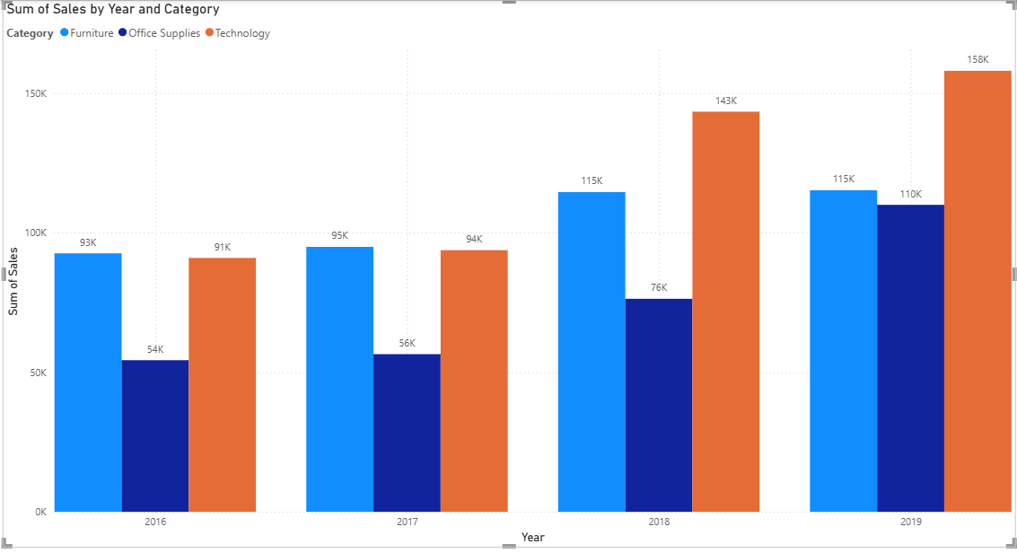

Create a Visual showing the top 5 products by profit
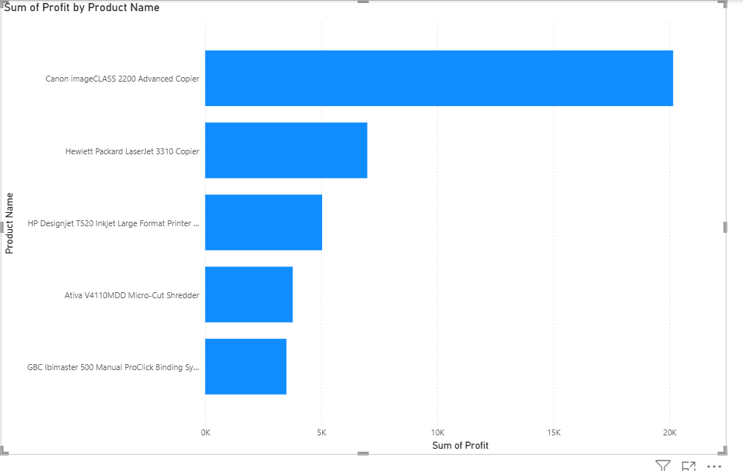

Create a visual Showing average profit by product sub-category
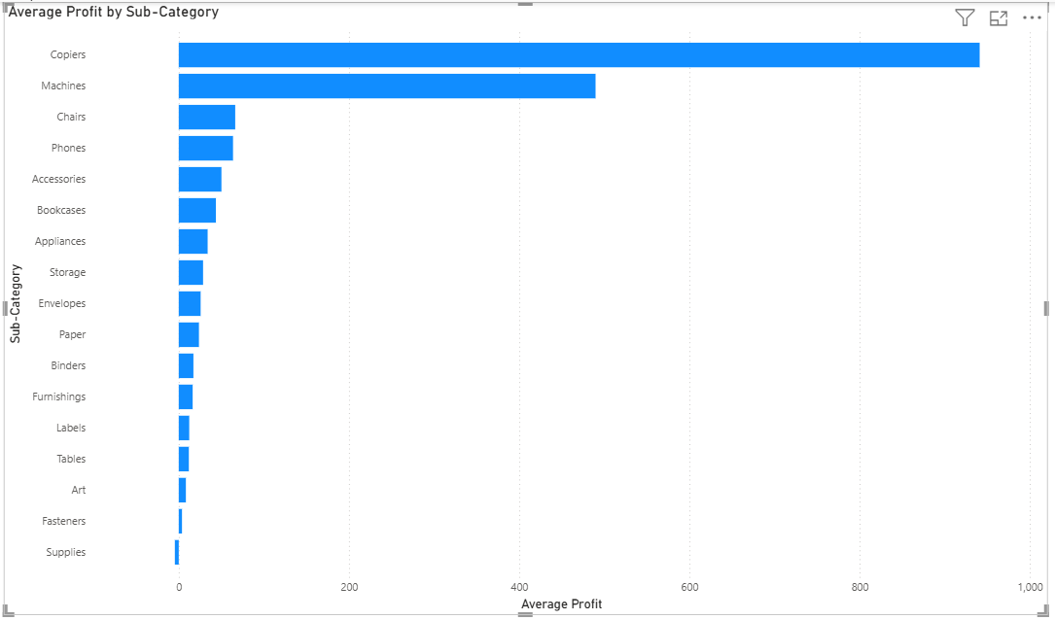
Create a Line chart showing monthly sales trend for top 5 customers
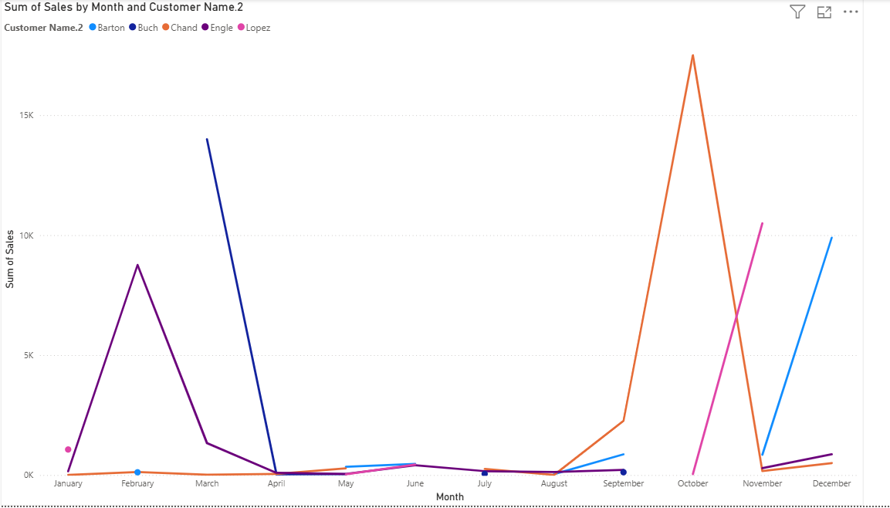

Create a chart showing sales contribution by region
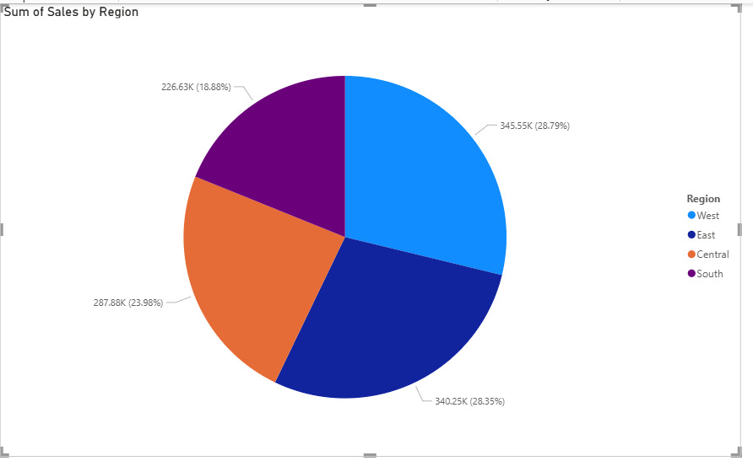
Create a chart showing total profit by month
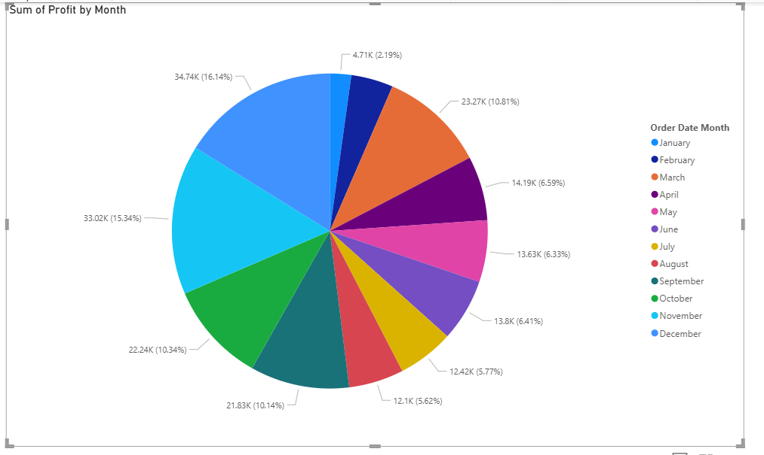
Create a chart showing average quantity sold by product category
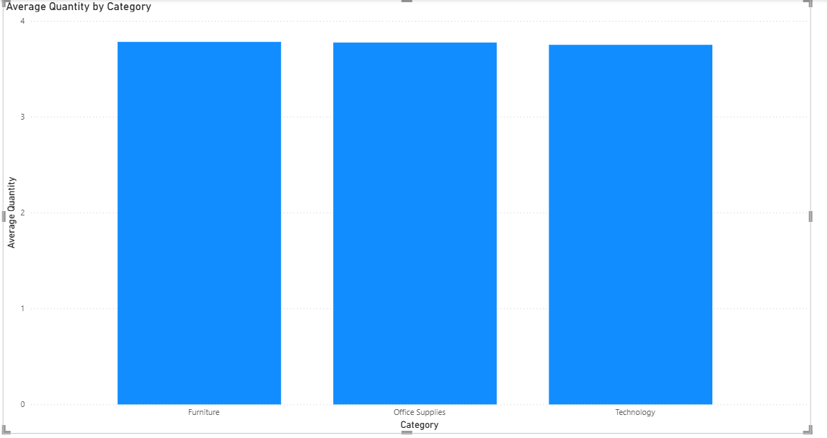

Create a Column chart showing sales by customer segment.
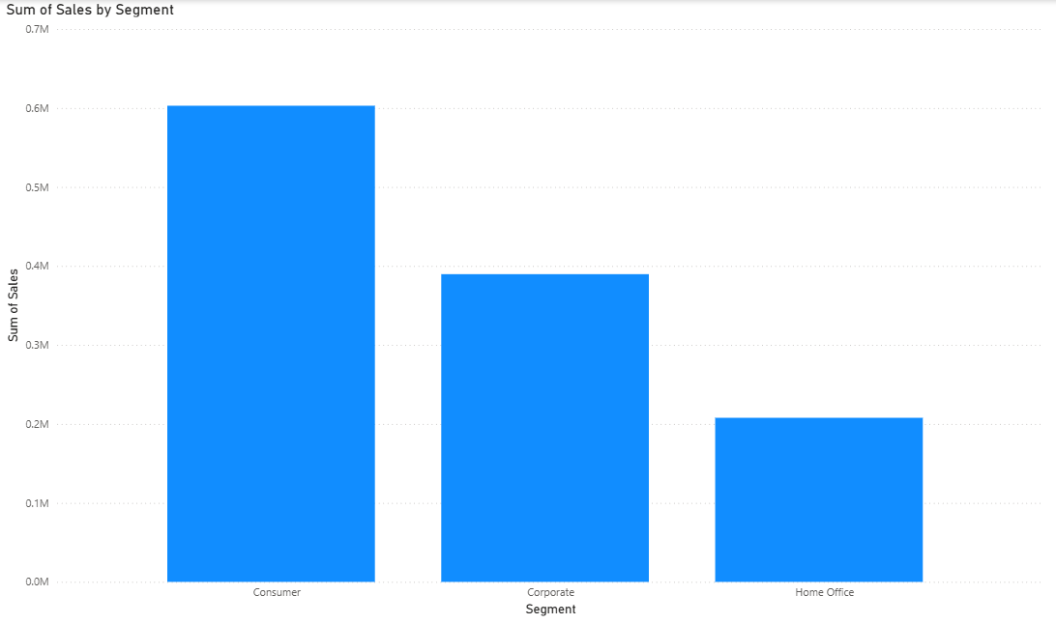

- Use Power Query to filter orders with Order Date in 2019. a. Showing total sales for filtered orders
Load Data into Power BI
Import your sales dataset into Power BI.
Go to Home → Transform Data to open Power Query Editor.
Filter Orders by Year (2019)
  - Select the Order Date column.
  - Use the Date Filters → Between option, or create a filter for Year = 2019.
  - Alternatively, add a column:
Year = Date.Year([Order Date])
Then filter rows where Year = 2019.
Calculate Total Sales for 2019
  - After filtering, close & apply changes.
  - In the Data Model, create a measure for total sales:
Total Sales 2019 = SUM('Sales'[Sales])
  - This measure will only reflect the filtered dataset (2019 orders).
Visualize Total Sales

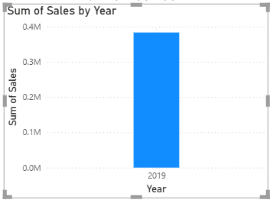
Add a column in Power Query for sales tax (10% of Sales). a. Create a chart showing total sales tax by product category.
• Open Power Query Editor
  - In Power BI, go to Home → Transform Data.
- Add a Custom Column for Sales Tax
  - On the ribbon, select Add Column → Custom Column.
  - Enter this formula:
SalesTax = [Sales] * 0.10
  - This creates a new column called SalesTax, which is 10% of the Sales value.
- Load Data Back
- Click Close & Apply to load the updated dataset into Power BI.

Remove duplicate orders based on Order ID in Power Query. a. Create a chart showing total sales before and after removing duplicates
• Open Power Query Editor
  - In Power BI, go to Home → Transform Data.
- Remove Duplicates
  - Select the Order ID column.
  - On the ribbon, go to Home → Remove Rows → Remove Duplicates.
This will keep only the first occurrence of each Order ID and remove duplicates.
- Close & Apply
- Load the cleaned dataset back into Power BI.
Split Customer Name into First Name and Last Name in Power Query. a. Create chart showing total sales by first name
Step 1: Load Data into Power Query
- In Power BI, go to Home → Transform Data.
- This opens the Power Query Editor.
🔹 Step 2: Split Customer Name
- Select the Customer Name column.
- On the Home tab, click Split Column → By Delimiter.
- Choose Space as the delimiter.
- Select Split at the left-most delimiter (this ensures the first word becomes First Name and the rest becomes Last Name).
- Rename the new columns:
- Customer Name.1 → First Name
- Customer Name.2 → Last Name
🔹 Step 3: Load Data Back
- Click Close & Apply to load the transformed data back into Power BI
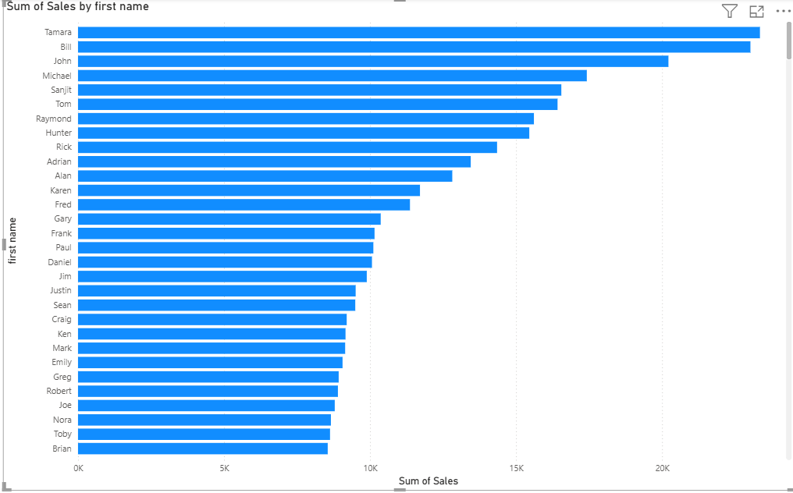

Group orders by year in Power Query and calculate average sales. a. Create a Line chart showing average sales by year.

Load dataset into Power Query (from Excel or Power BI).
- Ensure there is a Date column (e.g., OrderDate).
- In Power Query:
  - Select the OrderDate column.
  - Go to Transform → Date → Year → this will create a new column with the year.
- Now, go to Home → Group By:
- Group by the Year column.
- Operation: Average.
- Column: Sales (or your sales measure).
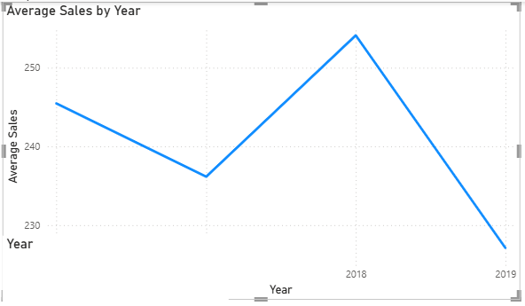
Create a custom column in Power Query for sales category (e.g., "High" for Sales > 100, "Low" otherwise). a. Create a Pie chart showing the distribution of sales categories.
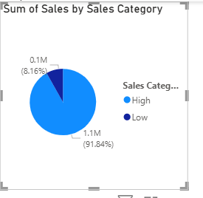
Create a Line chart showing running total of sales over time
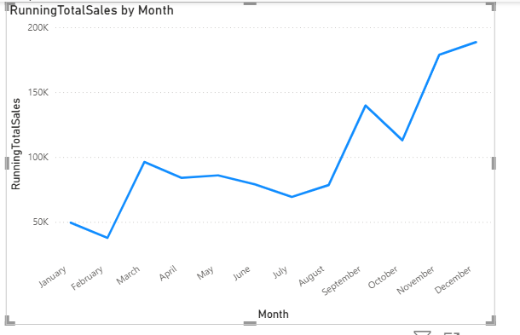
Filter orders with a discount greater than 0 in Power Query
• Load your dataset into Power Query
  - In Power BI Desktop, go to Home → Get Data → Excel/CSV/Database.
  - Select your sales dataset and click Transform Data to open Power Query.
- Locate the Discount column
  - In the Power Query editor, find the column named Discount (or equivalent).
- Apply the filter
  - Click the drop-down arrow on the Discount column.
  - Choose Number Filters → Greater Than…
  - Enter 0 as the value.
  - Click OK.
- 👉 This will keep only rows where the discount is greater than 0.
- Confirm the filtered data
  - You’ll see the row count decrease if discounts were previously 0.
  - Only discounted orders remain.
- Close & Apply
- Once the filter is applied, click Close & Apply to load the filtered dataset back into Power BI.
Create a chart showing total sales for orders with and without discounts
